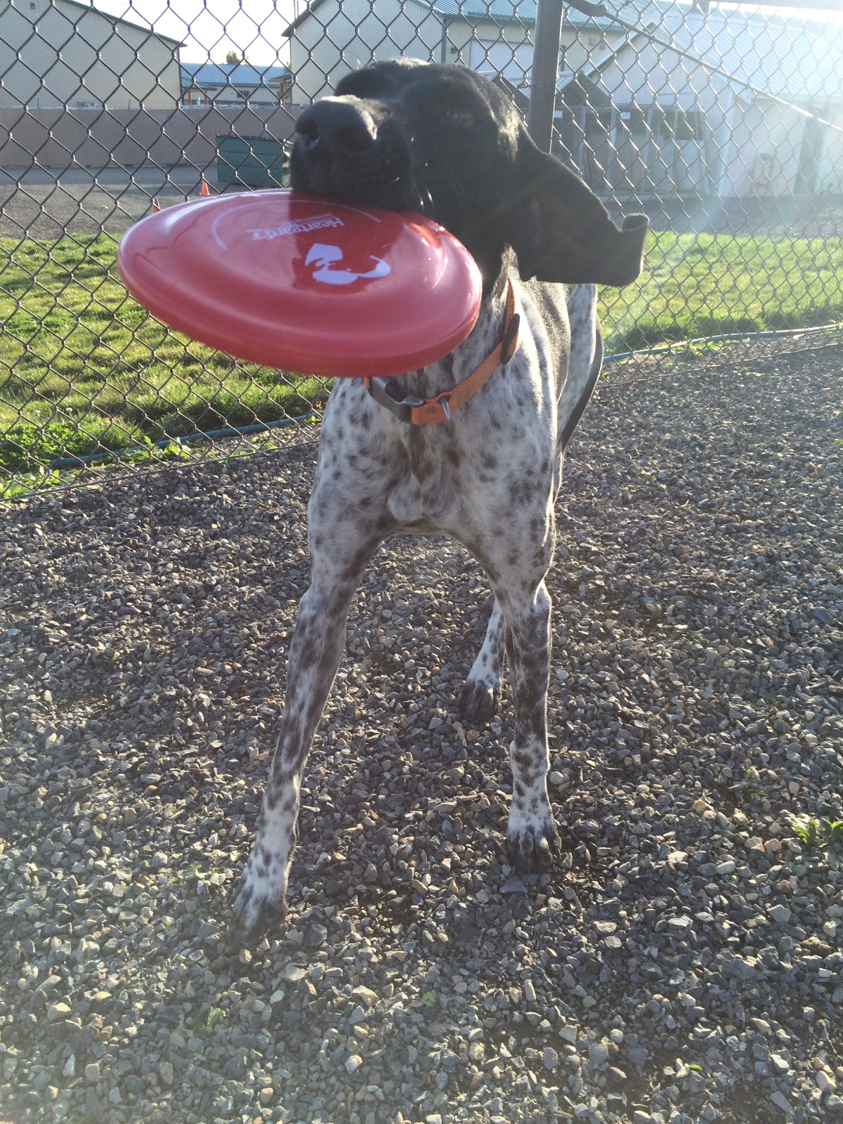
We offer boarding for cats and dogs at Valley Veterinary Hospital on a reservation basis. Boarding your pet with us will give you peace of mind as our veterinary care team is close by to help your pet through any issues that may arise while you are away. We can administer oral medications, insulin injections, and other treatments as needed. We provide all boarders with fresh water and clean bedding and tidy up their houses regularly. You can bring your pets’ regular food or let them enjoy our high quality sensitive stomach kibbles.
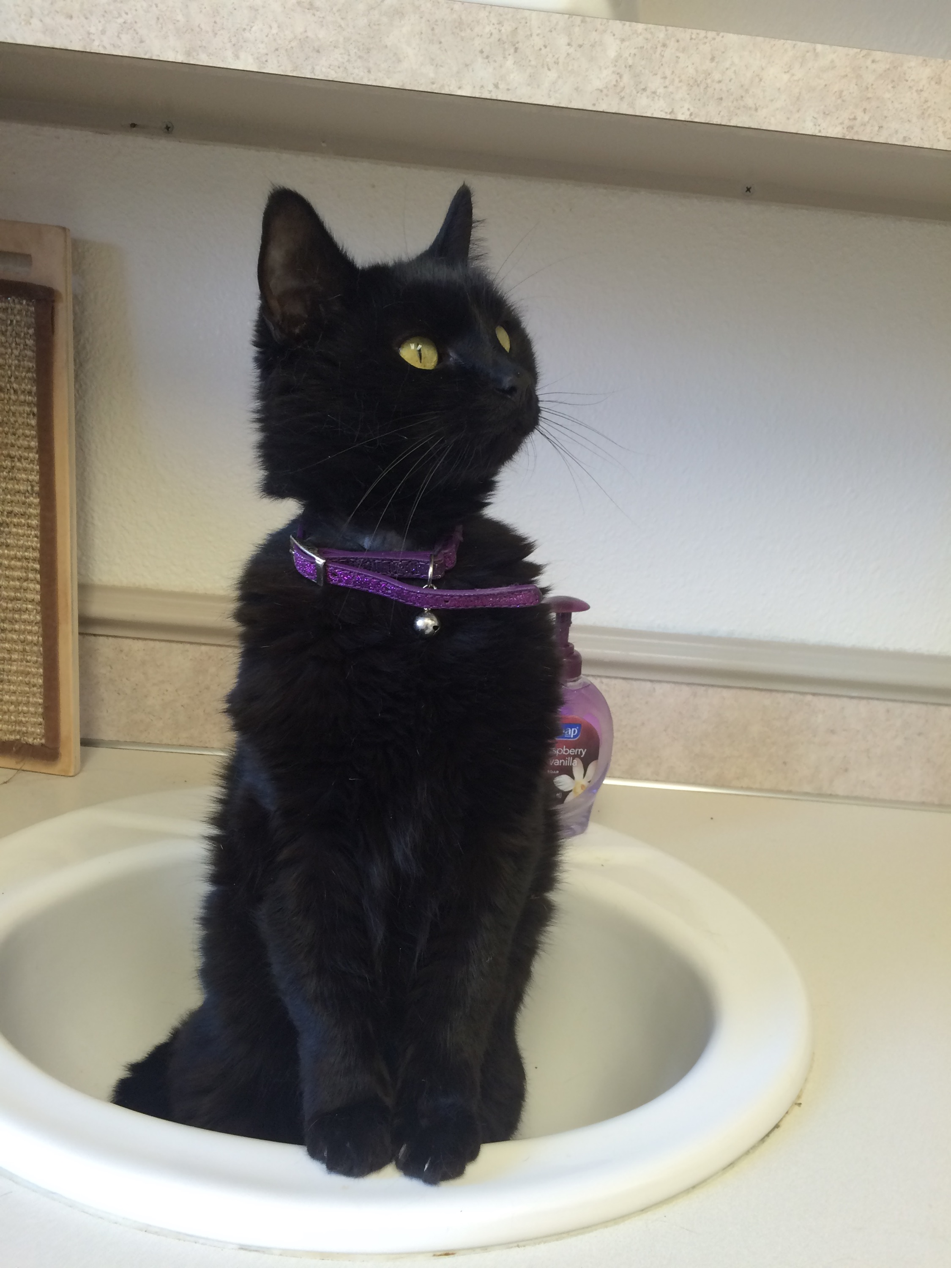
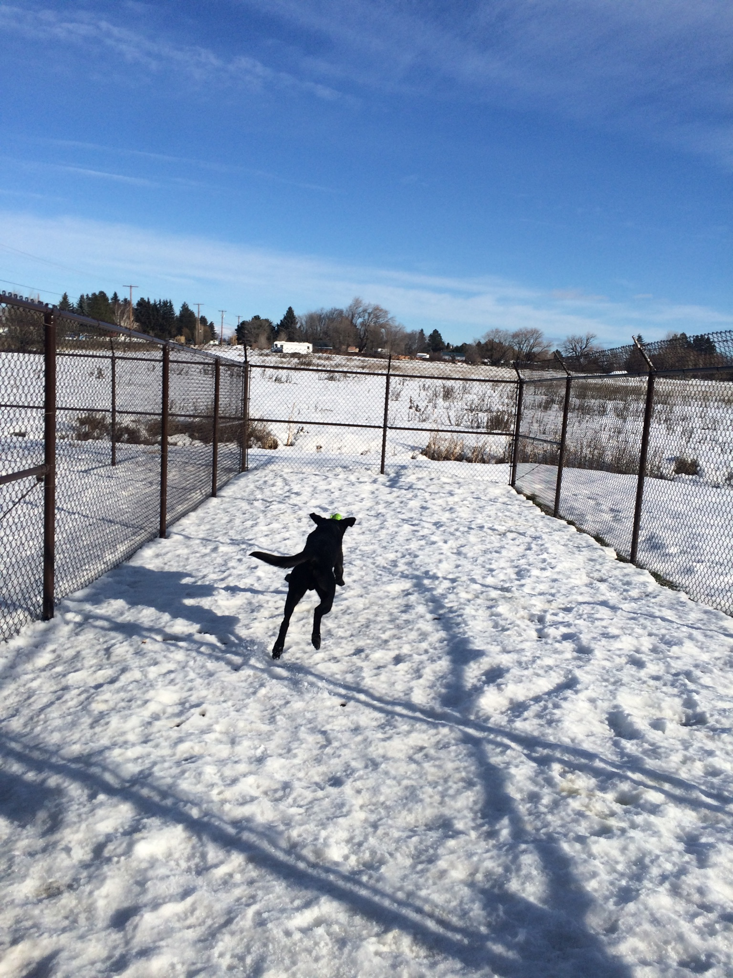
We recently completed a long awaited renovation and now have nine indoor canine runs that can comfortably accommodate up to two large dogs. Our kennel sizes vary and can house up to two small dogs so that buddies can stay together if they would like. We are also very excited to have a family suite which is incredibly versatile and includes an optional doggy door to an outdoor run and video monitoring! All dogs are let out into our new activity runs for 10-15 minutes three times a day. These runs are 15 feet by 48 feet and are directly attached to the dog rooms and suite so leashes are not required once your pet has checked in. All fencing is buried one foot deep with concrete basing under all gates and exterior fencing is angled inward at the top to prevent diggers and climbers from escaping. These runs are wonderful for playing fetch, sunbathing and watching the birds in the field next door. Gravel base is used to ensure good gripping for our older or unstable guests as well as keeping it easy to sanitize regularly. Astroturf is also available for those who prefer it.
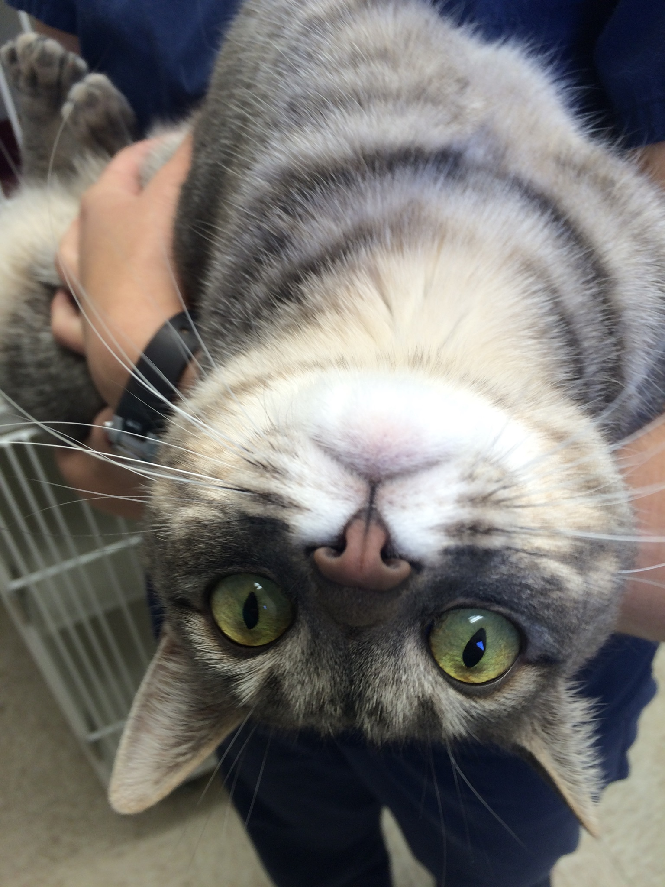
Our feline friends have their own room on the opposite end of the clinic from the dogs, which greatly helps reduce the amount of dog noises and smells they experience during their stay. When nervous kitties are staying with us we often use privacy curtains and Feliway (a calming feline pheromone) to help keep them as comfortable as possible. The new cat room offers 8 brand new cat condos with built in perches and pass-through tunnels. The tunnels allow us to open up multiple condos for your baby if you wish as well as giving us a low contact way to tidy houses of anti-social guests. We often take turns letting each kiddo out to roam the room to give them opportunities to explore, stretch and play or nap. The cat room window has a deep perch ideal for resting and watching the birds at the feeder outside! It also offers a scratching post, climbing perches and staff assisted laser pointer play-time!
In order to help reduce separation anxiety and stress during boarding stays, we proudly use low stress handling techniques, calming music and therapeutic grade aromatherapy.
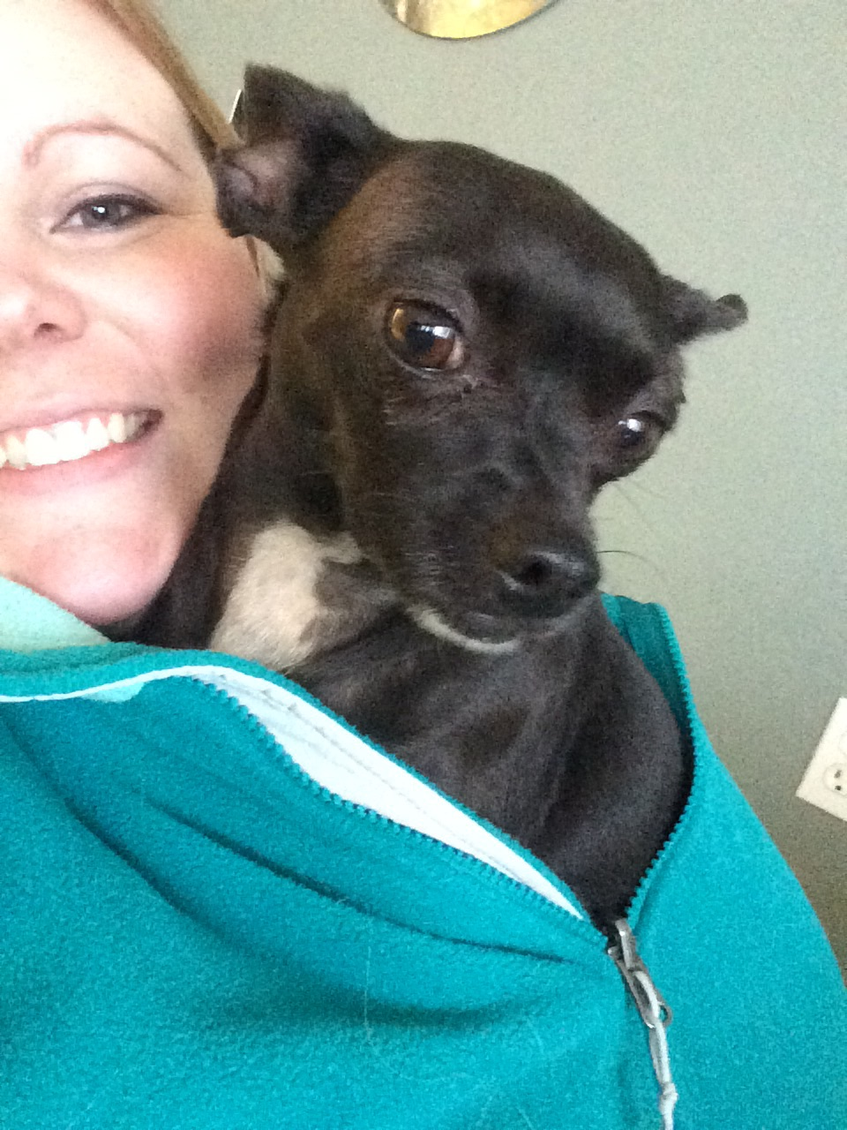
As boarding demand increased over the last few years, we were very excited to create a Boarding Manager. Melissa Wolford, L.V.T. first started with Valley Veterinary Hospital as an Animal Caretaker in 2006. She graduated from Yakima Valley Community College in 2012 with an Associate of Applied Sciences Degree in Veterinary Technology and received her license later that year before becoming a full-time staff member. Our Boarding Manager and Animal Caretakers rotate shifts to make sure your canine and feline kids are cared for from at least 7:00am-7:00pm on weekdays and throughout the weekends.
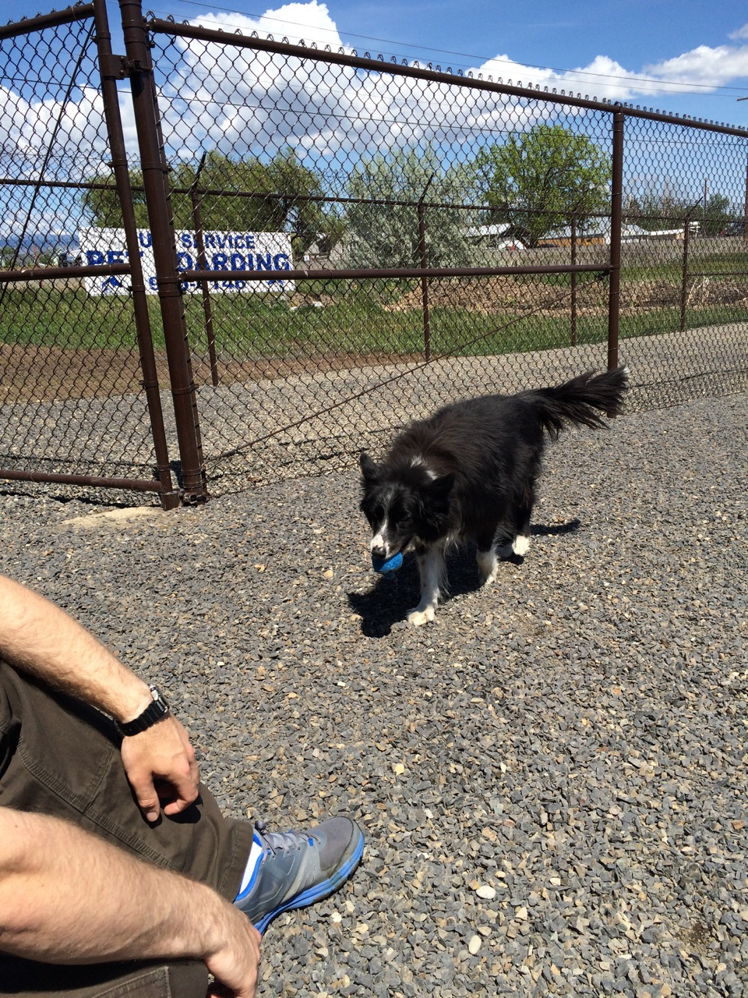
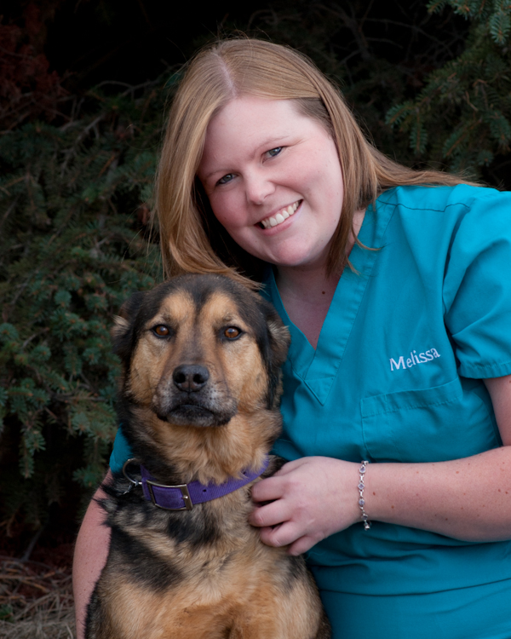
When you call for a boarding reservation, you will be transferred to the boarding desk where one of our dedicated boarding staff members will answer any questions you have and ask of few of their own to get us better acquainted with your furry kids prior to their stay. They will also confirm vaccine status and help you decide which space or extra amenities are best for your pet(s). When you arrive, we will help you complete our boarding policy sheet where we learn about your pet’s normal habits, your concerns and how to get in contact with you if we need to while you are away. We will also give your pet a brief complimentary exam to check for any obvious external health concerns while they are here. If you would like to see and/or fill out the policy in advance to save some time at check-in, it can be downloaded from our ‘Printable Client Forms’ page on this website or you can swing by and pick up a copy! We are happy to send e-mail or text message updates as we are able while you are away!
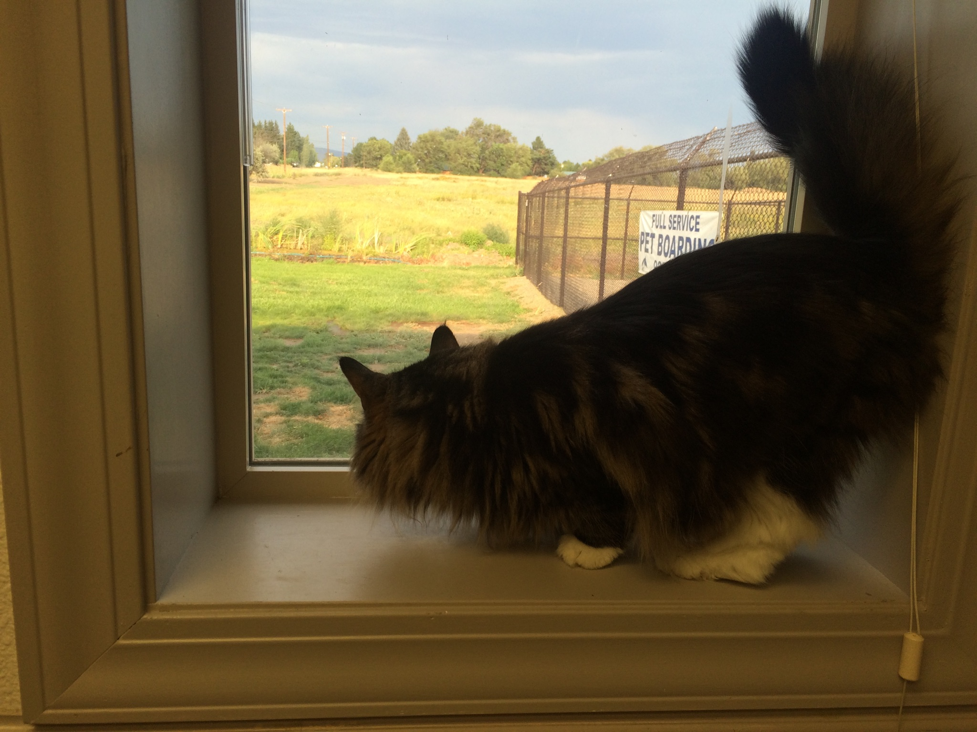
Starting in 2016, the boarding lobby now has it's own business hours! Boarders can be checked in or out Monday-Friday 8:00am-11:30am and 2:00pm-5:00pm, Saturday 8:00am-11:30am and Sunday evenings by appointment from 4:00pm-6:00pm. Each Holiday is unique so be sure to ask what our scheduled check-in and check-out times are near the holiday you are booking for. Melissa's goal, and ours, is to make you feel as relaxed as possible while you are away and to make every pets stay unique, just like they are! If you have any questions please feel free to call us at 509 925 6146, send a text message to 509 653 5533 or send an e-mail to valvetboarding@fairpoint.net!
Frequently Asked Questions:
Q: Can I have medical appointments, prescriptions refilled and/or grooming done while my pet is boarding? A: Yes! When you call to make reservations, be sure to ask and we will schedule exams, dental cleanings, nail trims, etc. during your pets stay. Jenn's Pet Parlor is located inside the boarding building and she is often able to accommodate baths and grooming during their stay! You can reach Jenn at (253) 245 0791.
Q: What should I bring with my pet? A: You are not required to bring anything but you can bring almost anything! We serve a sensitive stomach dry kibble but are more than happy to keep them on their normal diet while here if you bring it with them. Their houses are completely their own so feel free to bring some bedding and toys along. We are not here 24 hours a day and therefore cannot take responsibility for damage that occurs to your belongings. We have a plethora of bedding and bowls and will add to whatever you bring from home :)
Q: Can my cats and dogs stay together? A: Yes! We currently have one family suite that allows us to make a unique space for each family. It does have a doggy door to the outside runs but it can easily be closed and blocked off during such a stay so that the cat(s) cannot escape. The suite books up quickly so be sure to make reservations in advance! We have two other spaces that can also be used as suites at this time. The Exam Suite was once an exam room and makes a wonderful space for quiet dogs, dog and cat combinations or large cat families. The Barn Suite was originally an equine surgical stall and is fully padded, making it ideal for older dogs that find slick floors challenging.
Q: What if my pet needs extra outside time or has special medical needs? A: We are more than happy to accommodate as much as we can! Our standard requests and the associated fees are located on the boarding contract and we are always happy to answer any questions you have or give you a quote!
Q: Melissa cannot work constantly. Who comes in to take care of our kids when she is not here? A: We have some wonderful Animal Caretakers who rotate shifts. Matt, Cord, Danielle, Alicia, Vaile and Ashley love to spend time with our boarders. Feel free to say hi when you are in the hospital and check out our staff photos in the hospital lobby!
Q: Is the building air conditioned? A: Yes! During our recent renovation both the ducting and A/C unit were upgraded so that all areas are climate controlled.
Q: When can I pick up and drop off my pet(s)? A: We are open Monday-Friday 8:00am-11:30am and 2:00pm-5:00pm, Saturdays 8:00am-11:30am and Sundays 4:00pm-6:00pm. The lunch time closure on weekdays allows us the opportunity to give our guests our full attention for mid day activities and care and guarantees that our staff members get a break. You may request after hours check-ins or check-outs which are subject to availability and incur an extra fee to account for the additional staff time.
Q: Do my pets need to be vaccinated and treated for fleas prior to their stay? A: We do not currently require that boarders be on a flea preventative as all guests are checked for evidence of fleas at arrival. We do highly recommend it, however, as fleas and ticks are present in Kittitas County. This is especially important in the Spring and Summer months. Vaccines are required to board. We require dogs to be up to date on Rabies, Distemper/Parvo and Bordetella vaccines. We are not currently requiring the Canine Influenza vaccine but do highly recommend it. Cats are required to be up to date on Rabies, FvRCP and FeLV. If you have questions about when these vaccines should be boostered for them to be considered up to date, please do not hesitate to call! We do accept home vaccinated pets but must know what product was used on what date. It is important to know that vaccines purchased and given at home do not carry the same guarantees as veterinary administered vaccines.
Q: How can I get ahold of you while my pet is in your care? A: 1. You can call Valley Veterinary Hospital at 509 925 6146. During business hours you can ask for boarding and will be transferred to us (during our lunchtime closure you will be able to leave a voicemail). 2. You can send boarding a text message at 509 653 5533. Even when the hospital is closed, one of our staffers is constantly monitoring this line. This number is linked to a computer and therefore we cannot answer or make phone calls. 3. You can send boarding an e-mail at valvetboarding@fairpoint.net. We check for messages throughout business hours and periodically on weekends.

